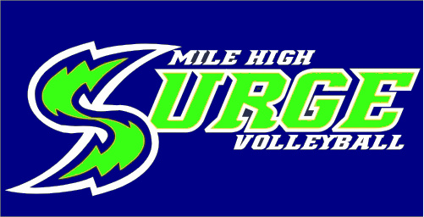

Information Form

Player name _____________________________ Age Division(s) for tryouts________________

Address______________________________________________________________________

City______________________________________ State _____________ Zip_______________

Birth Date _______________ Height ____________ Handedness (circle one) RIGHT LEFT

Desired Position ________________________ Position Last Played ______________________

Previous Club Experience: Club _________________________ Team ____________________

High School/Middle School _______________________________________________________

Parent’s Name(s) _______________________________________________________________

Home Phone ________________________ Player’s Cell Phone _________________________

Mother’s Day Phone ______________________ Mother’s Cell Phone_____________________

Father’s Day Phone _______________________ Father’s Cell Phone ____________________

Parent Email __________________________________________________________________

Player Email___________________________________________________________________

T­Shirt size (unisex) ____________________________________________________________
_____Player Info Sheet
_____RMR Spectator Code of Conduct
_____Copy of Birth Certificate

_____$250 Deposit – Cashed only if position on team accepted
_____$25 Try Out Fee Non-Refundable
_____RMR Membership

Staff Use Only
$25 Try Out Fee made payable to:
Mile High Surge VBC
Current RMR Membership or Summer Tryout Membership is required. Visit www.rmrvolleyball.org and click on the membership tab.

